**DOCUMENTATION FOR SCENARIO-3:**

**What is Scenario-3?**

* **Alice is a user of the WINGS WORKFLOW SYSTEM.**
* **Alice created a workflow for Converting an html file to text file.**

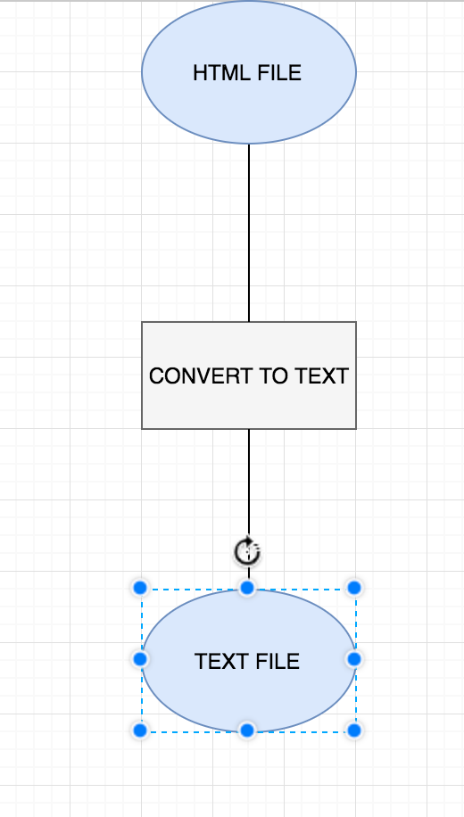

* **Alice, wanted to extend this workflow to create a sorted text file. So now, she modifies this existing workflow to a different one.**

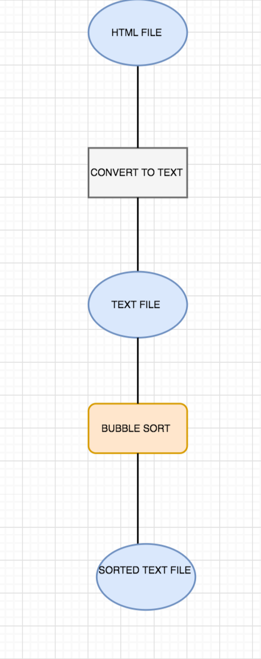

* **When Alice creates this new workflow, it should be noted that the workflow is a revision of her previous workflow and hence we have linked them together.**

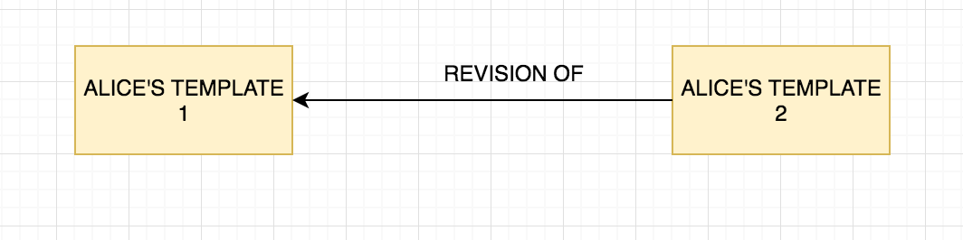

**Important Aspects about the code:**

* **We are creating a signature for the abstract template that will determine the uniqueness of the template with its parameters, data vars, outputs, components and all other links**
* **This hashed version of the signature helps us identify uniqueness among templates.**
* **Further, we have now exported an issued time property in the abstract template export in OPMW.**
* **This will help us identify changes in current templates have occurred when exactly.**
* **We use this factor for determining which template is going to be a revision of which one here.**
* **This was taken into effect as compared to the last modified time, since it is not correctly exported in the WINGS template from WINGS. (It can be only used for date changes BUT NO TIME CHANGES)**